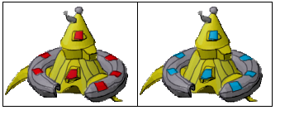

Barracks, used for creating all the units, except Workers.

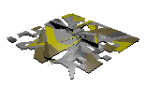

Big Debris, this is used when big buildings are destroyed

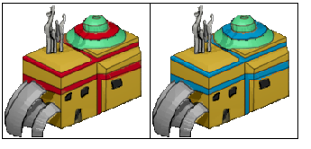

Central Refinery, used to create Workers

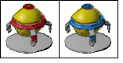

Energy Core, for increasing the limit of unit creation...

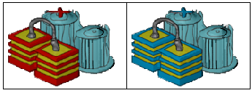

Energy Engineering Node, for creating Solar Towers

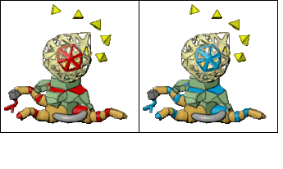

Experimental Storm Bay, for creating Thunder Makers

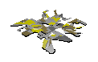

Little Debris, used when small buildings are destroyed

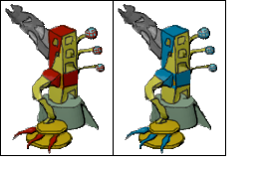

Pulsar Facility, to create Pulse Cannons

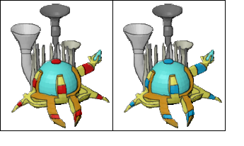

Quantum Dispatcher, used to create Solar Birds

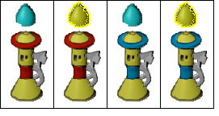

Solar Tower

C:\Users\Mariano\Java\Strategy\graphics\cursor\move.png

Cursor animation when issued an unit to move there

C:\Users\Mariano\Java\Strategy\graphics\cursor\over_e.png

C:\Users\Mariano\Java\Strategy\graphics\cursor\over_n.png

C:\Users\Mariano\Java\Strategy\graphics\cursor\over_y.png

Cursor animation for when you place your cursor over an enemy, neutral, or yours unit...

C:\Users\Mariano\Java\Strategy\graphics\cursor\select.png

Cursor graphic when trying to select various units

C:\Users\Mariano\Java\Strategy\graphics\cursor\static.png

Cursor idle animation...

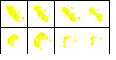

Solar bird impact shoot (graphic used when the projectile impacts)

C:\Users\Mariano\Java\Strategy\graphics\effects\solar\bird_imp.png

Solar bird animation when it shoots... (graphic that appears near the solar bird)

C:\Users\Mariano\Java\Strategy\graphics\effects\solar\bird_sho.png

Solar bird projectile animation...

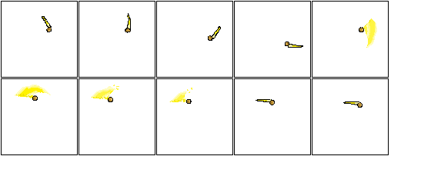

This is the Light Warrior sword animation, it's separated because it always goes in front of all the other graphics...



Base when it is ready to be casted



Base in process



Explosion for a big building



animation used on a building when it's busy creating an unit or doing research..

C:\Users\Mariano\Java\Strategy\graphics\effects\cannon_fire.png

The pulse cannon projectile

C:\Users\Mariano\Java\Strategy\graphics\effects\cannon_imp.png

The pulse cannon projectile with it impacts...

C:\Users\Mariano\Java\Strategy\graphics\effects\cell.png

This is casted by a Thunder Maker over an unit, this is a magic cell, it freezes the enemy unit for a while...

C:\Users\Mariano\Java\Strategy\graphics\effects\fire1.png

C:\Users\Mariano\Java\Strategy\graphics\effects\fire2.png

C:\Users\Mariano\Java\Strategy\graphics\effects\fire3.png

These fire animations are used when a building is damaged...

C:\Users\Mariano\Java\Strategy\graphics\effects\mage_explo.png

This is the explosion the Thunder Maker does when it dies...

C:\Users\Mariano\Java\Strategy\graphics\effects\mage_imp.png

This is the impact of the attack the Thunder Maker does



This is the explosion for the Pulse Cannon death



This is the magic shield that the Thunder Maker creates.... you should make it more trasparent...



This is a shockwave storm created by the Thunder Maker



Explosion for a small building

C:\Users\Mariano\Java\Strategy\graphics\effects\sword_imp.png

The impact the sword makes...



Explosion used when the worker dies...

C:\Users\Mariano\Java\Strategy\graphics\effects\worker_imp.png

Impact the Worker does when it attacks..

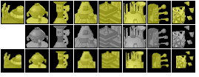

For the HUD, these are the icons for the buildings... gray means you can't build it.... smaller yellow means your are clicking it...

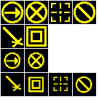

From left to right and from up to down...

Move, Stop, Attack, Cancel, Harvest, Build

C:\Users\Mariano\Java\Strategy\graphics\icons\info.png

For the info HUD, the first one is how much minerals you harvested, the second one is the unit limit...



The panel... for HUD

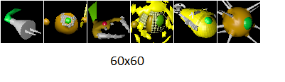

The portraits for the units...from left to right you have:

Worker, Light Warrior, Solar Bird, Thunder Maker, Pulse Cannon, Buildings...

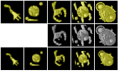

The units icons...

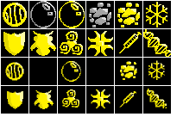

Icons for the different upgrades... from left to right and from up to down I'm going to name the first two rows:

it's developed by default - Cast a magic cell (thunder maker)

Develop Energy Forcefield - Cast an energy shield

Develop Energy Shockwave - Cast a storm

Energy Cooldown - More magic for the Thunder Maker

Nova Shields - More defense for units...

Tera Shields - More defense for units

Colomerix Energy Handler - More attack for units

Orcut Energy Handler - More attack for units

Density Injection - Solar bird shoots further

Adrenaline Shot - Light Warrior moves faster

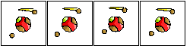

Light Warrior

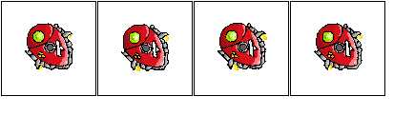

Pulse Cannon (without the cannon graphic)

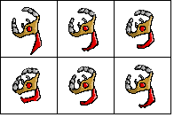

Solar Bird

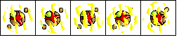

Thunder Maker (doesn't use walking animations because it glides)

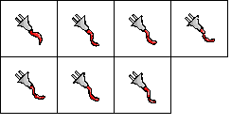

Worker

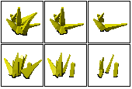

Crystals to harvest

C:\Users\Mariano\Java\Strategy\graphics\units\crystal.png

Crystal that was harvested and is brought by a Worker